**Grafana with AWS Cloud**

1.     Goto Google and search for “Grafana.com” Click on create a free account.

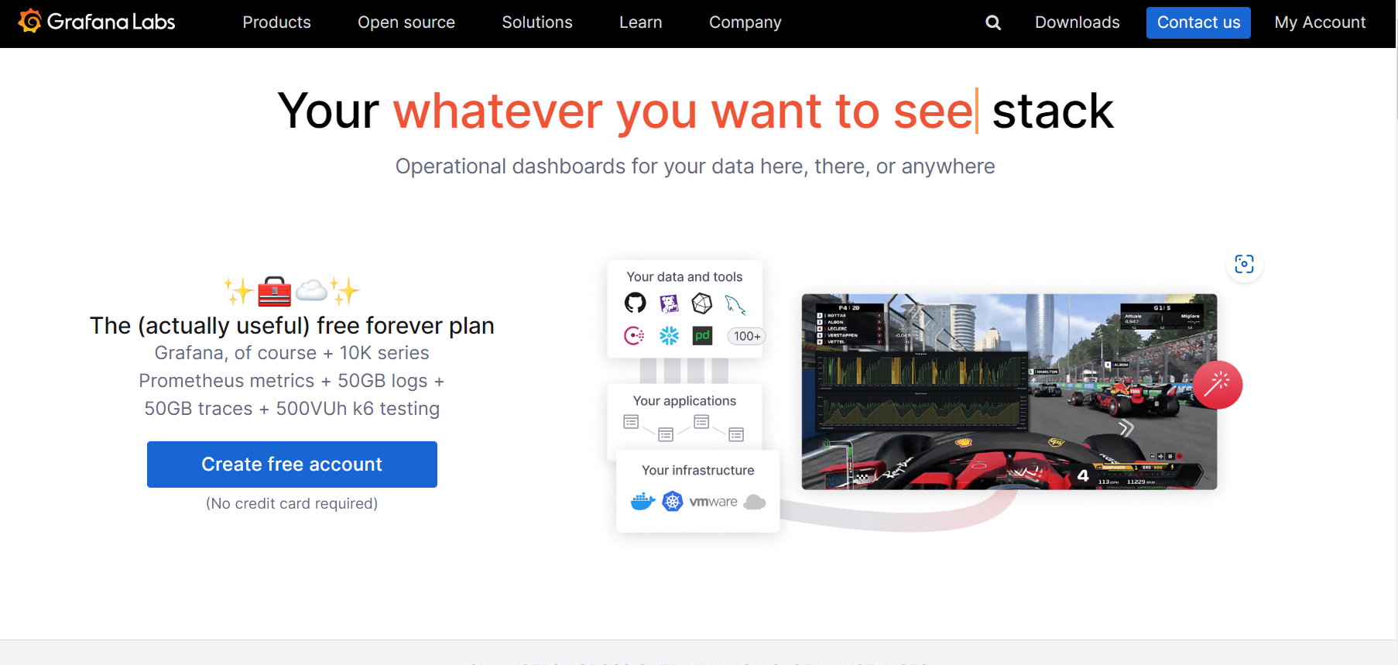

2.     You can create your account with your ease. Create account

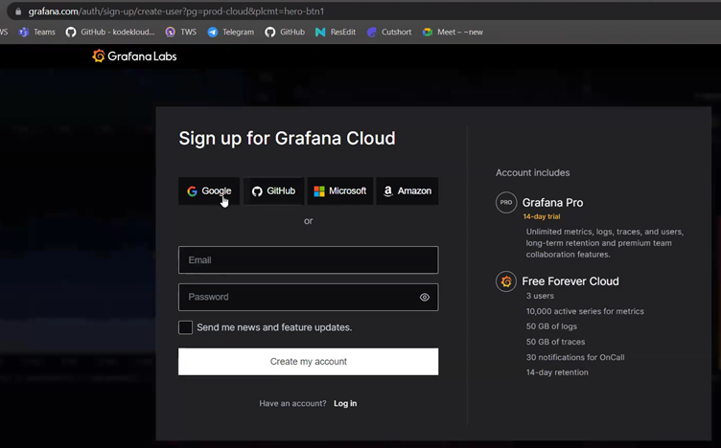

3.     Now select Team URL and the Deployment Region, and click on “Finish Setup”

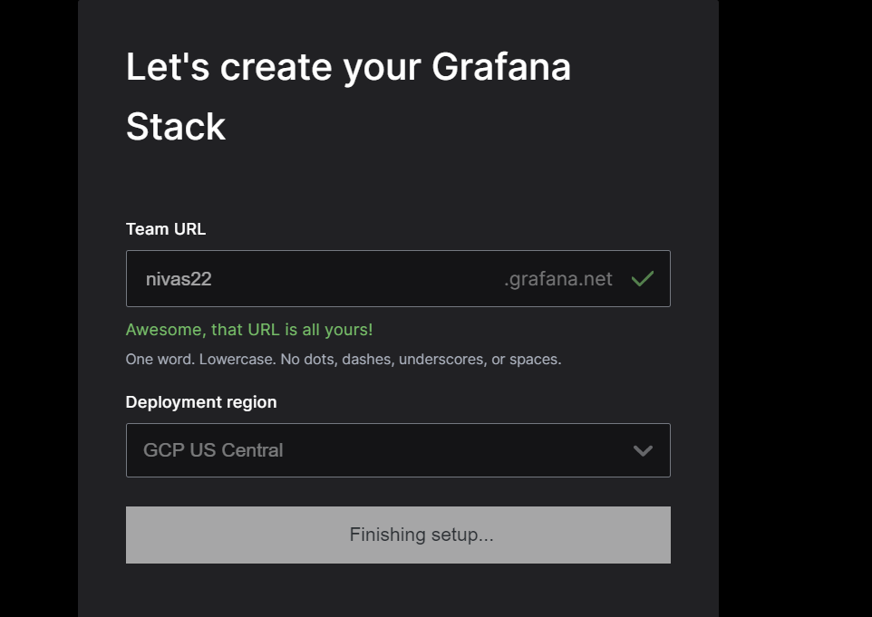

4.     Here, Grafana is creating an instance for us in the background.

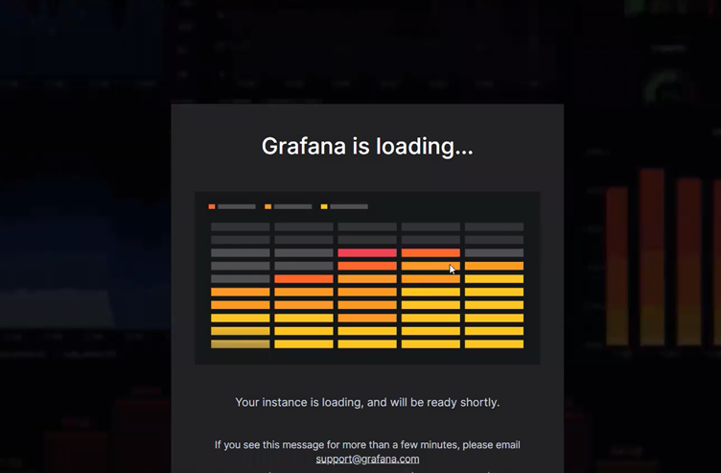

5.     As of now, we will just be “Creating a Dashboard”.

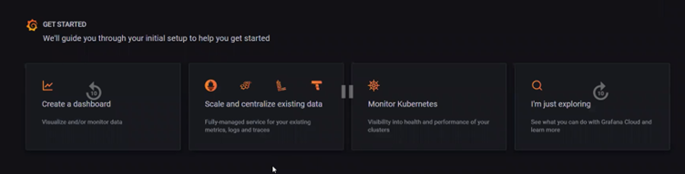

6.     Here, from a lot of options we will select “Linux Dashboard”.

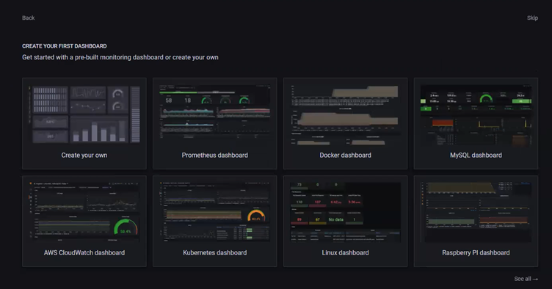

7.     It will give you a template, to create a dashboard for Linux.

In Choose your OS: Debian – based

Architecture: Amd64

Hostname: <Public IP of EC2>

Click on “Install Integration”

(Here is a YAML file below, that Grafana will run in the background to generate logs for any particular instance).

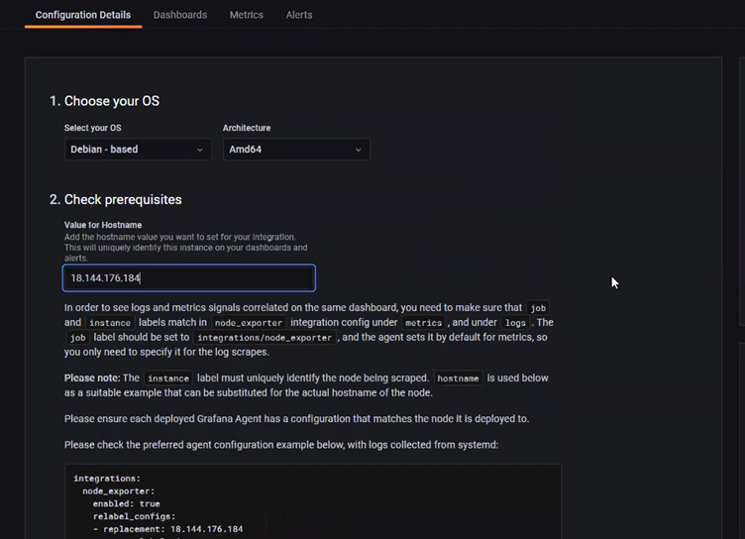

8.     After doing “Install Integration” it will create a custom installation for you. It will create an API key, by using this key our Grafana cloud and EC2 instance will connect.

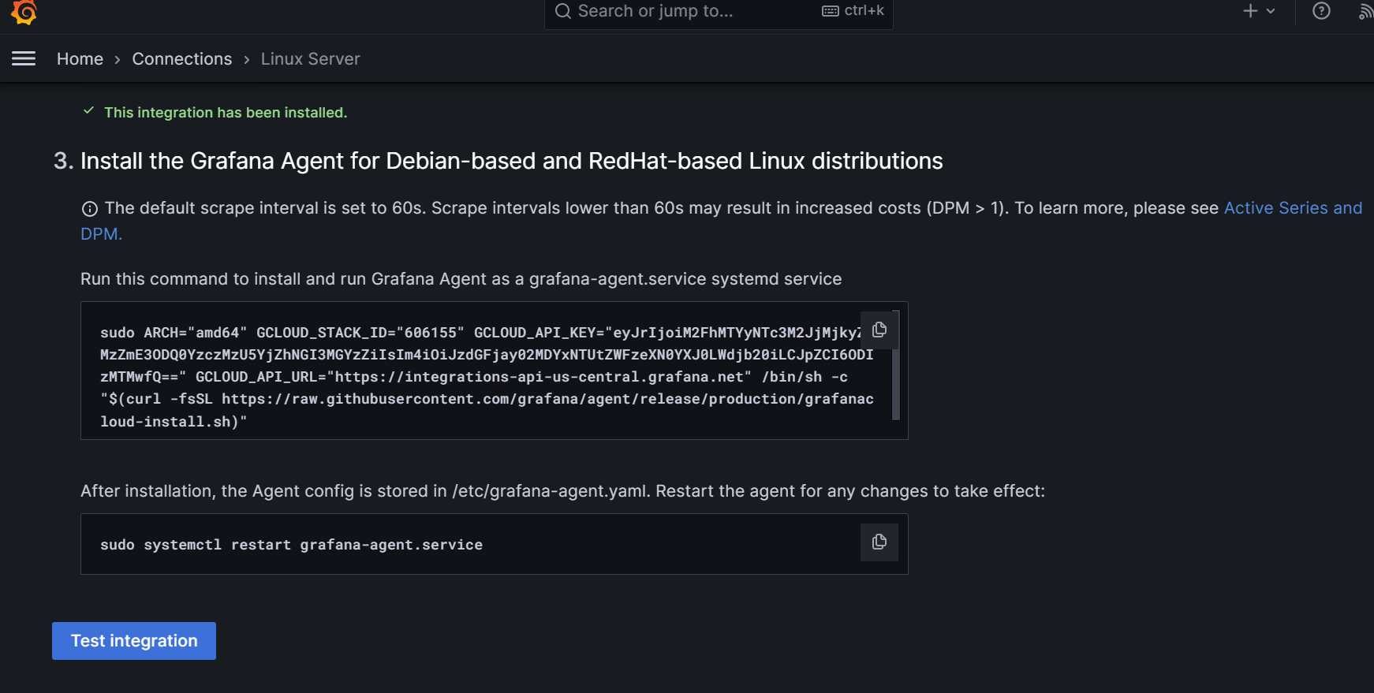

9.     Copy the above key and SSH to the server that we created earlier, and paste that Key. It will start to install it.

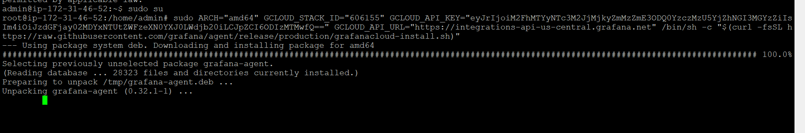

10.  Now, run the command to restart the Grafana agent.

“sudo systemctl restart Grafana-agent.service”

11.  Now, check the status of the agent if it is running.

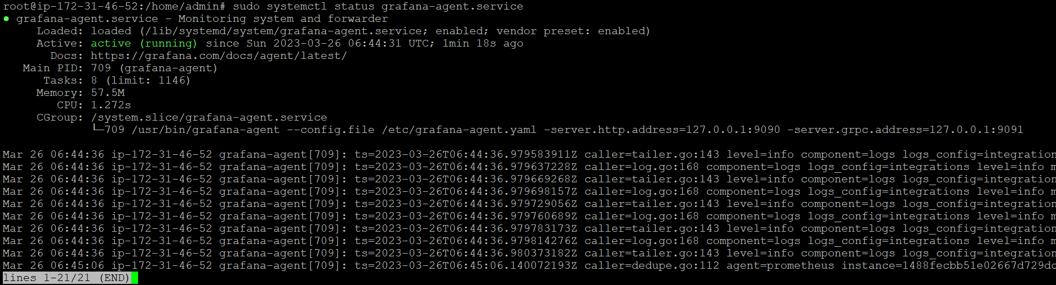

12.  Now, go back to Grafana Dashboard and click on “Test Integration”

13.   Now, click on “View Dashboard”

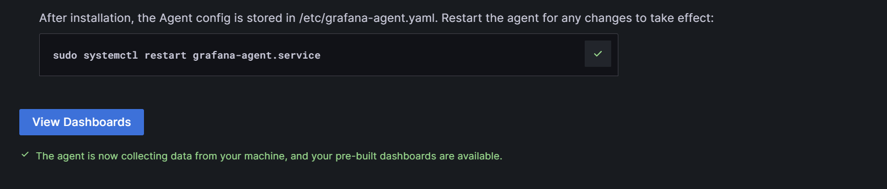

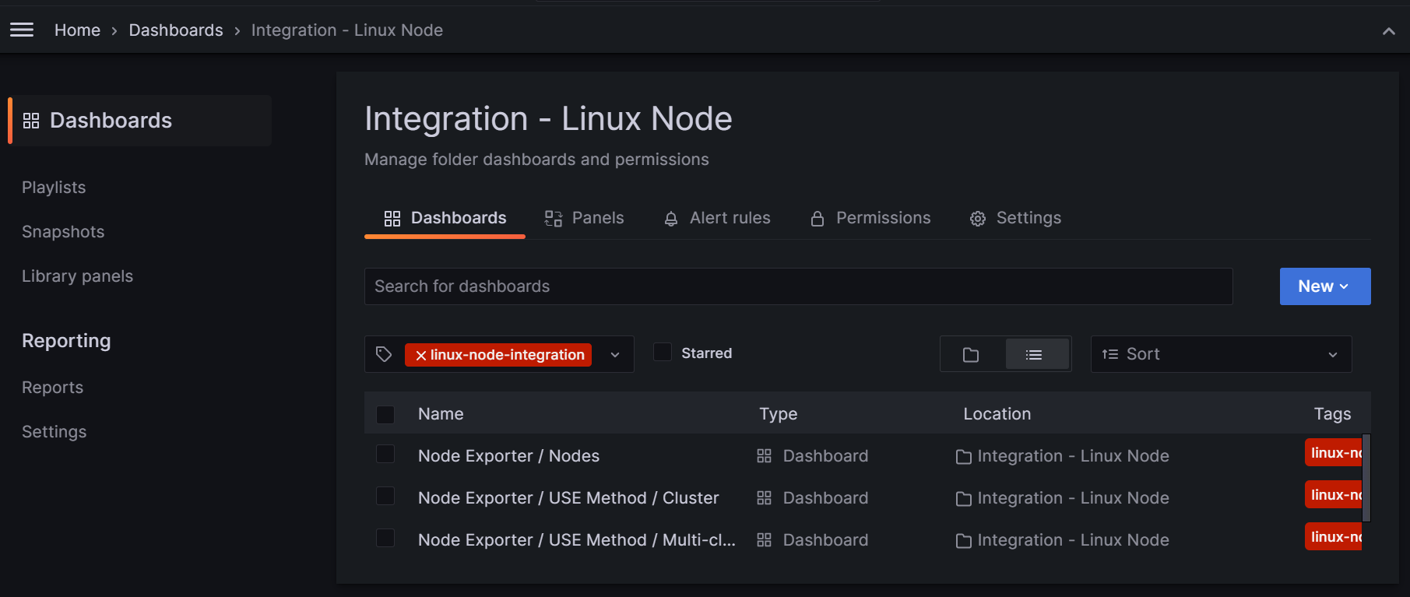

14.  Now, Go to “Node Exporter / Nodes”, and you will get all your Server monitoring on Grafana.

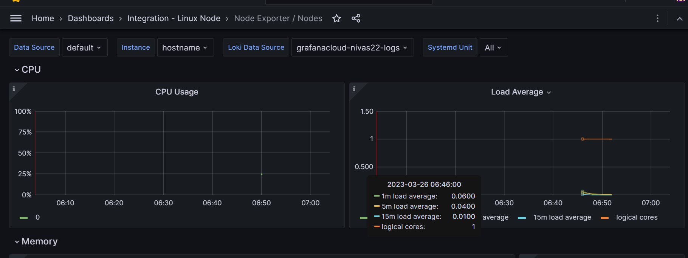

15.  To make the graphs up, just run some docker containers on the newly built server and it will start showing the data.

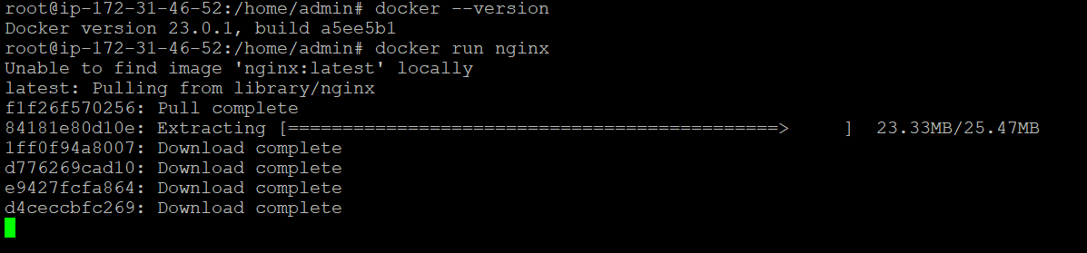

16.  As it started heating up,

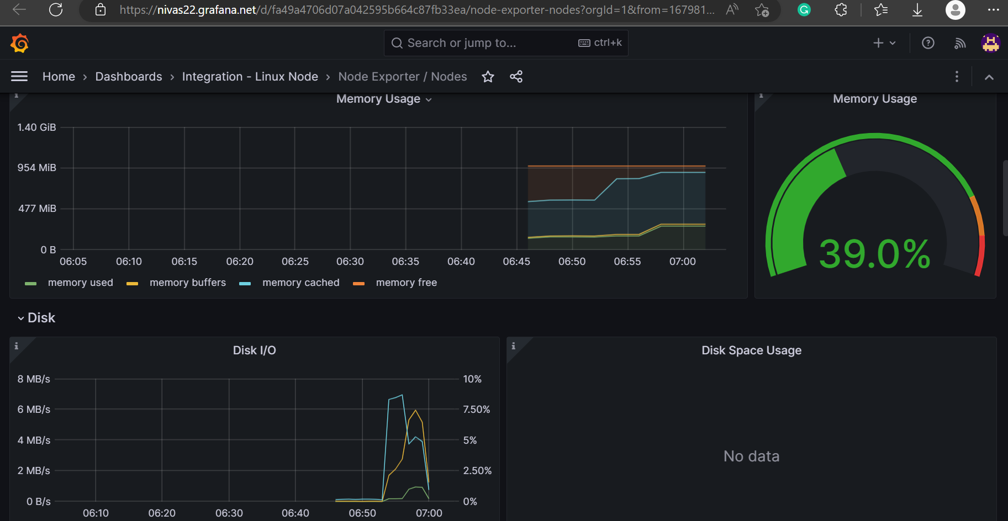

17.  Now, click on “+ Connect Data”.

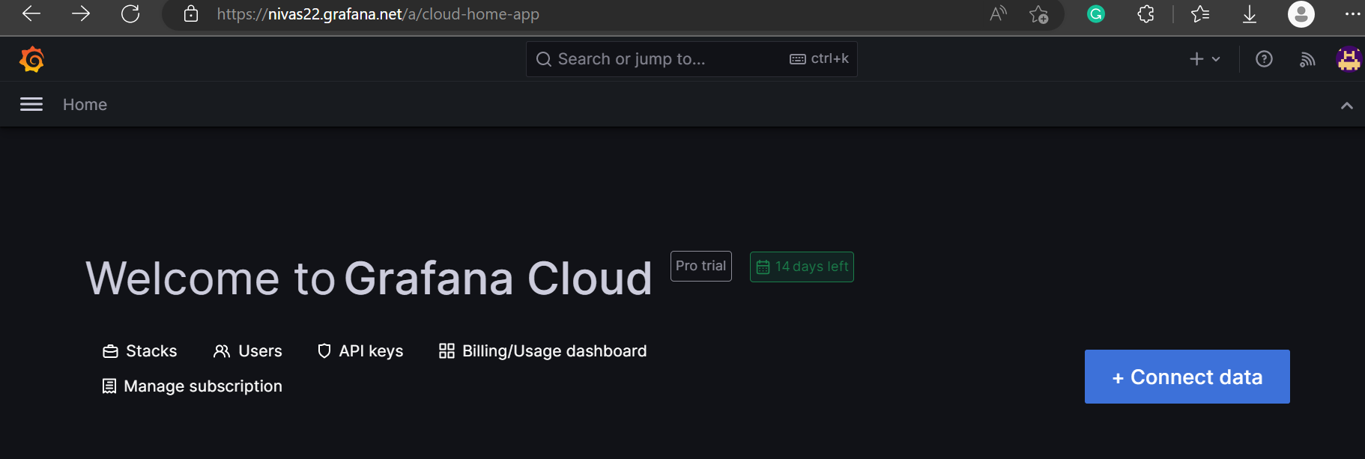

18.  It will list down, all the things that you can integrate with Grafana.

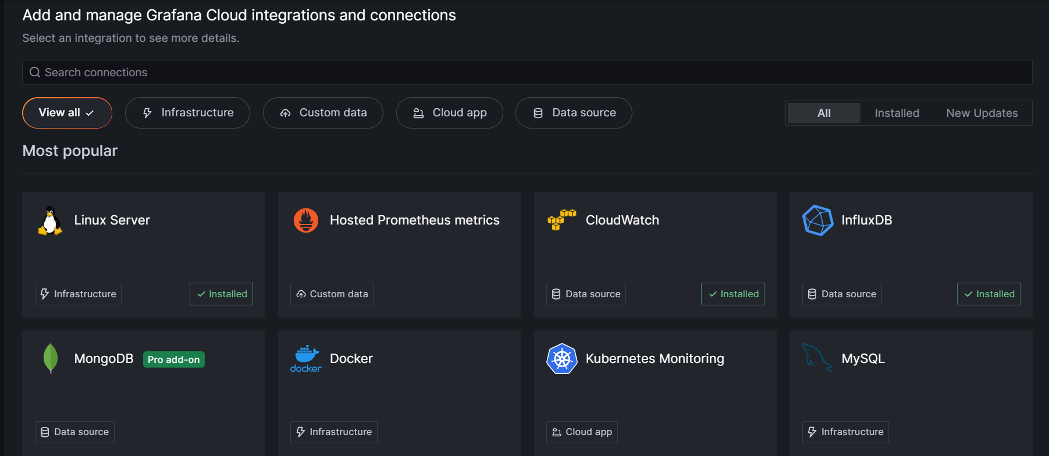

19.  Now let’s click on “CloudWatch”.

20.  Goto “Create a Cloud Watch Datastore”.

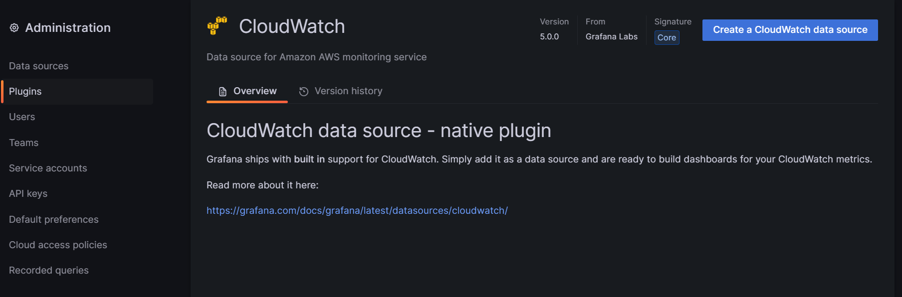

21.  Here, we need to give the Username and Password, of a User with Programmatic Access from IAM.

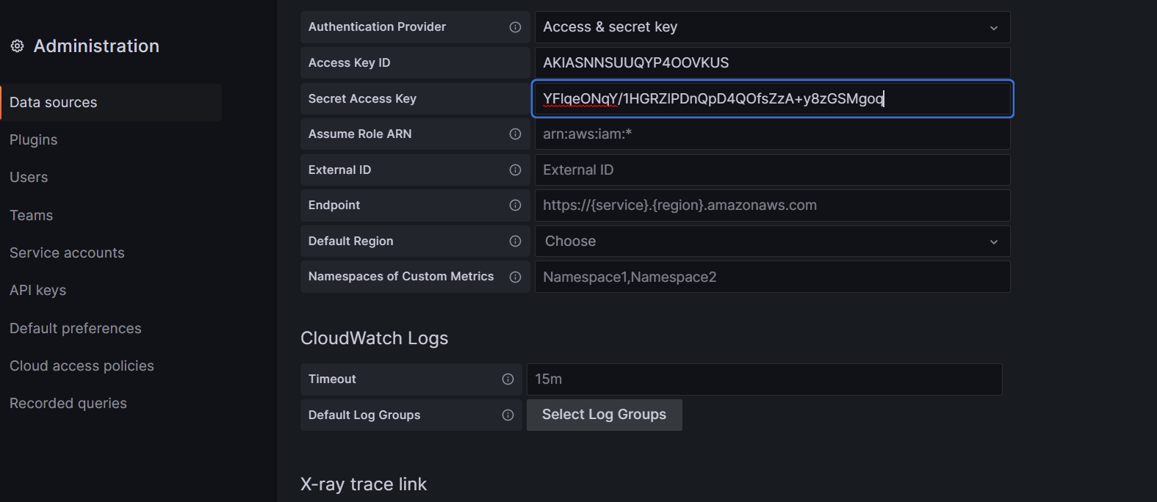

22.  Select Region “us-east-1” as cloudwatch by default uses this region.

23.  Now click on “Save and Test”.

24.  Now, create any type of alarm in “CloudWatch”.

25.  Suppose we have created a billing alarm for a limit of $10.

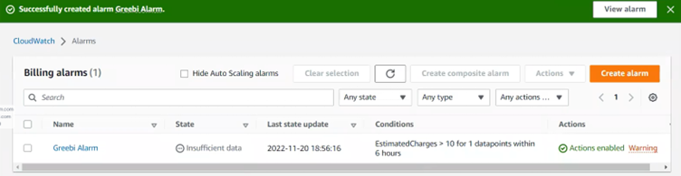

26.  Now, go back to Grafana and refresh.

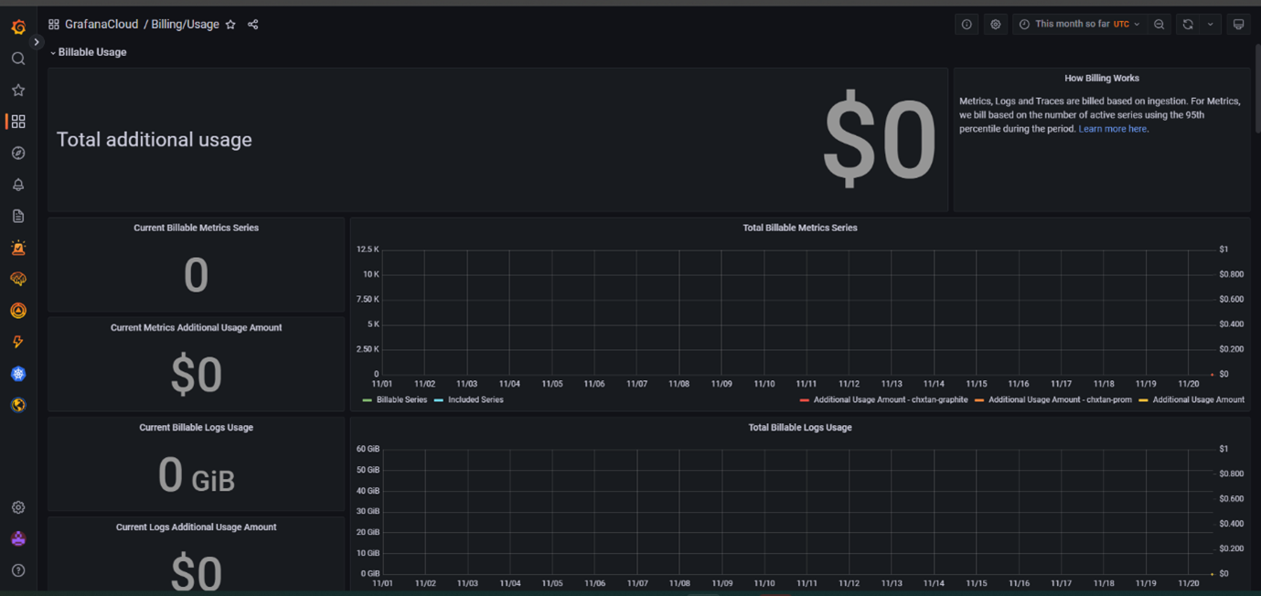

In the same way, we can create dashboards for Docker, Kubernetes, and a lot of other services.